Does A New Environment Mean A New Person?

Every year seniors graduate from high school, ready to embark on a new journey. Some go to work straight from high school, while others attend two or four year colleges and universities. When they leave for college, the general consensus of the students is that “they will not change unlike others in previous years.” But when the students return home for Christmas Break, there are obvious differences. Being juniors last year Jessie and I were friends with a large proportion of the senior class. When they went away to college we began to notice a change in a great amount of them. For example, one friend, “Susan” who came home to visit from San Diego State University, wore much more make-up and her style of clothing was more risqué than prior to her new habitat. While a senior at Amador, “Susan” was a very religious and had a strong faith. She attended church almost every Sunday, was in a small group, and did devotionals every night. While talking to her during her winter break, she hadn’t gone to church at all during the year and she wasn’t in any type of a small group at college. A few friends that returned from California Polytechnic State University that had not previously been in the party scene were now in the party scene. While we were brainstorming for our project the topic came up and we decided it would be interesting to experiment with this topic. We wanted to know if it was limited to the few extremes mentioned above or if it was a common occurrence among college age students. We wanted to see if and how college students adapt to their environment.

Another reason why we chose this topic was while walking through the campus one day we noticed the vastly different cliques. We were curious and wanted to know if you were to throw another person into the group, if they would adapt to the new group or would they be shunned out or perhaps never “fit in”. Also, from personal experiences, we notice that people are different when they are around different people. To one group they may come off as intellectual, but when they get around a different group of people, they become witty. Since it would not be feasible experiment to thrust people into different groups of friends and see how they react, we decided on the exploring the differences in college students since we know they have been put into a different environment, different people, it is the closest we could come to the scenario discussed above.

Natural selection is the major form of adaptation; it is what most people look at when they research how organisms adapt. Natural selection is the overall change in a species over time. We are interested in a small form of adaptation: how a person changes its behavior when thrust into an entirely different environment. While at home, living with parents, teenagers have a desire for freedom but at the same time restrictions from the parents. When they are removed from the parental environment, most teenagers have never experienced life without the rules and regulations parents have always set on them and are in a completely different environment. This new found freedom does have an effect on the changes a person experiences, but we question how large of an impact it has on first-year college students. We speculate what exactly changes these young adults. One thought is that it could just be the difference in people that causes this change. Some believe that human cognitive abilities have come about through the process of evolution.

The whole study of adaptation is based upon the hypothetico-deductive method, which is referred to as the scientific method. This is what we based our experiment upon. First there is a development of a scientific hypothesis, ours being If students go away to college, they will change based upon their new surroundings. One must be able to make predictions through deductive reasoning to test a hypothesis. The prediction is an expected outcome which can be observed and either verified or falsified.

Adaptations, which can be involuntary or voluntary, are adjustments in practices, processes or structures to take account of changing climate conditions. Impacts are sometimes difficult to identify. Impacts can be subtle but significant, and their consequences can differ for different members of the same community. For example, some see change as a loss and others see it as a gain. This changes the whole community.

The brain is a perfect example of how when something is changed, then the body will adapt to the new. It was thought that brain functions are limited to certain areas of the brain. However, this is refuted when one looks at a case such as epilepsy in a young child. In severe cases, a full “hemispherectomy,” (removal of half of the brain) is the only option. When the procedure is successful not only are the seizures eliminated, but the child can function as well or almost as well as any other child. The brain is able to recover the function that the other half of the brain usually does. This is a form of adaptation. The brain adapts so that if the left side of the brain is removed and that is supposed to control language, the right side of the brain will develop a language center and there will be a minimal amount of differences. Just as the body adapts to physical changes inside, changes on the outside affect the behavior of a person.

In order to complete this project we needed to research other scientists’ experiments with adaptation and see what had been explored. The basic facts that we discovered in almost every experiment included the following discussed below. The biological definition of adaptation is: change to suit environment: the development of physical and behavioral characteristics that allow organisms to survive and reproduce in their habitats. The physiological definition of adaptation is diminishing sensory response: the diminishing response of a sense organ to a sustained stimulus. Adaptation is a relative term; it involves an alteration in something to something. In order to describe the adaptation it requires the specification of whom or what adapts, the stimulus for which the adaptation is undertaken, and the process and form it takes. There is a large variety of forms when it comes to adaptations. It can be anything from a change in the temperature to switching habitats. Adaptation types have been differentiated according to numerous attributes. Factors that have been used to differentiate adaptations are purposefulness and timing. “Autonomous or spontaneous adaptations are considered to be those that take place as a matter of course.” This means that they occur as a result of something else happening. For example, if a person moved from California to Minnesota, they would remember their jacket as they walked out the door.

To be able to predict when adaptations occur, there must be knowledge of the processes involved in adaptation decisions. This “knowledge” is information on “steps in the process, decision rationales, handling of uncertainties, choices of adaptation types and timing, conditions that stimulate or dampen adaptation, and the consequences or performance of adaptation strategies or measures.” These decisions can be undertaken by private individuals, local communities, national governments, and international organizations. In our experiment, we are focusing on how private individuals make decisions that effect their adaptations. They make decisions based on what is best for the situation they are in. This shows how a decision that would be made by an individual in one environment may not be the same decision they would make in a different environment. This reflects our upcoming experiment because in college, they are free to make decisions without repercussions. This is an adaptation reflecting the research presented above.

People react to change in a similar way they react to traumatic events. The reaction process has four stages: denial, anger, mourning, and adaptation. The final stage, adaptation is the step where the person accepts the need to change and get on with their life. The duration of time in each stage is different for each person, but studies show that however small, people do go through these steps when reacting to a change. When adapting, people have a need to know what is happening to them and how it will affect them. Since sometimes this is in the form of information, empathy, reassurance, and feedback, gossiping and griping are common occurrences. Scott Adams, the writer of Dilbert, says that people “hate change.” The reason for this is because change makes us “stupider because our relative knowledge decreases every time something changes.” People avoid communicating with others when they are changing because doing so means dealing with issues such as feelings.

A man by the last name of Chickering theorizes on the development of a college student. He describes a series of developmental phases through which an individual moves during the life cycle. Each phase is created by the convergence of a particular growth phase and certain tasks. Chickering’s theory of student development focuses on the college student. He presents a model of student development derived from his research on undergraduates and the works of others. He has postulated seven vectors of development rather than the developmental tasks or developmental stages used by other theorists. The seven vectors are as follows: achieving competency, managing emotions, developing autonomy, establishing identity, freeing of interpersonal relationships, developing purpose in life, and developing integrity. These concerns exist all along in a person’s life, but they become much more important during the college years and students work on resolving different vectors at different points in time. The resolution can be positive or negative and either way it will affect the future vectors.

Chickering’s theory states why students change so much when they leave for college. They are in the most developmental years, so their minds are trying to figure out a way to grow and achieve the kind of life they want to. While in high school, they feel they have their entire life ahead of themselves. But once in college, they are leading themselves into their future lives. What they do in college will effect them forever. But Chickering also points out that while they are trying to follow the seven vectors, it does not always work out because they are off on their own, living as they never have before. This is why college students the first few years tend to lose some maturity instead of gain it.

Hypothesis

A change in the environment will change the actions of the person, the thoughts of the person, and the reactions of the person. When in a different environment, people can’t act the same in every situation otherwise they won’t be successful in their community.

Prediction

If people adapt to their environment, then we will find that they have different studying habits, partying habits, different tastes in music, clothing, etc. or they hang out with different types of friends at college.

Materials Needed:

1. E-mail addresses of 50+ first-year college students.
2. identical survey
3. Research

Experiment

We first came up with questions that we felt would best represent a broad range of how a person could change in college. Questions that were not biased were impossible to come up with because how someone changes is based on how they and others see them before and after. We then made a list of freshmen college students we knew and sent them an email asking them to fill the survey out. We picked randomly out of the college freshman we knew to try to be unbiased. We decided that if we sent them to at least fifty people, then we could get at least thirty back. Although 30 surveys is a small sample size, we felt that with that amount of surveys we would have data that showed differences in college students. When deciding who we would send the survey to, we picked different types of kids and ones that went to different colleges. We did not want all of our data to come from students from one college. We ended up getting surveys back from kids all around the country, which adds to our variety of students. Once we sent them to the freshmen, we waited until they sent them back. When they sent them back we tallied up their answers, reading their responses in each different category. We made sure to keep the male and female responses separate so that we knew at the end if there was a difference in the way male and females adapt to changes in their environment.

Survey

Hey! This is a survey for AP Biology. Please help us and answer honestly. In order to get the best results possible, please make sure and take this by yourself so no one is having an impact on your answers. Also, please do not discuss your answers with anyone until after you have returned it to us. We need the results as soon as possible so please respond ASAP. Also, please send this to all your first-year college friends to fill out.

Age:

Male or Female?

What time of day are you taking this survey?

How far away from home are you?

On a scale of 1 to 10, how different is the environment that you are living in from the one before you attended college?

Have you noticed a change in yourself?

Has anyone noticed a change in you?

What kind of changes have you noticed in your friends from high school?

What were your friends like in high school?

What kind of people do you hang out with in college?

Did you keep your room clean in high school?

How has your room been kept this year?

How many times a month did you party in high school?

How many times a month do you party at college?

What type of music did you listen to in high school?

What type of music do you listen to now?

What type of music did your friends listen to in high school?

What type of music do your friends in college listen to?

What were your study habits in high school?

What kind of study habits do you have now?

Data

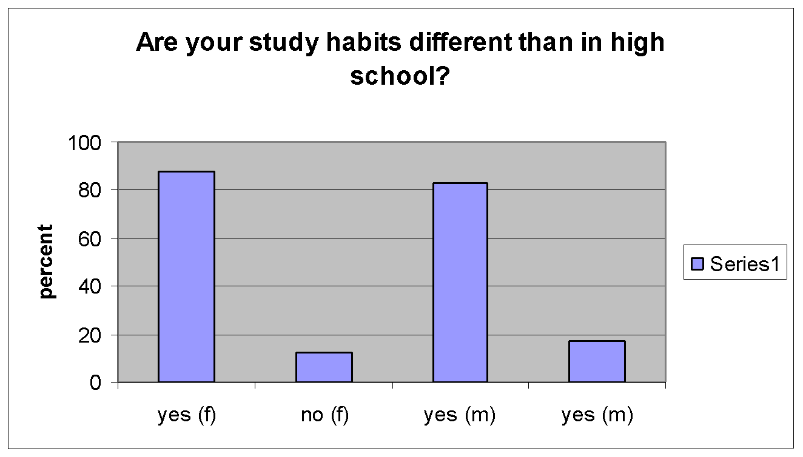

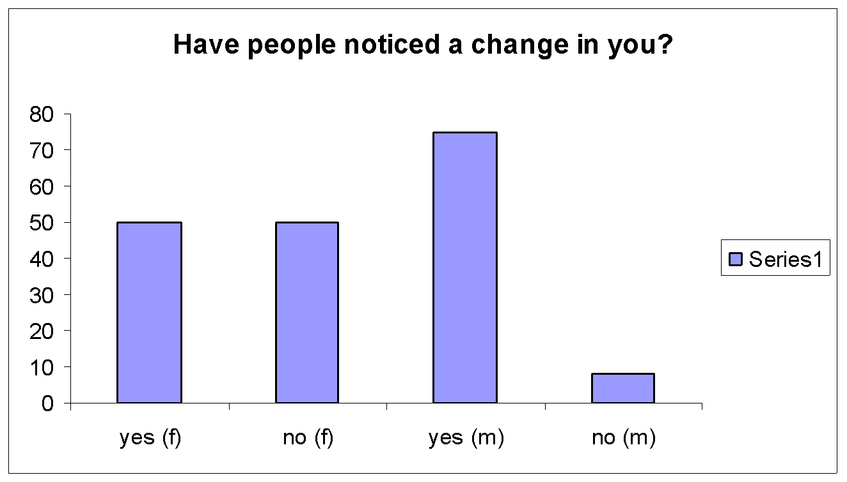

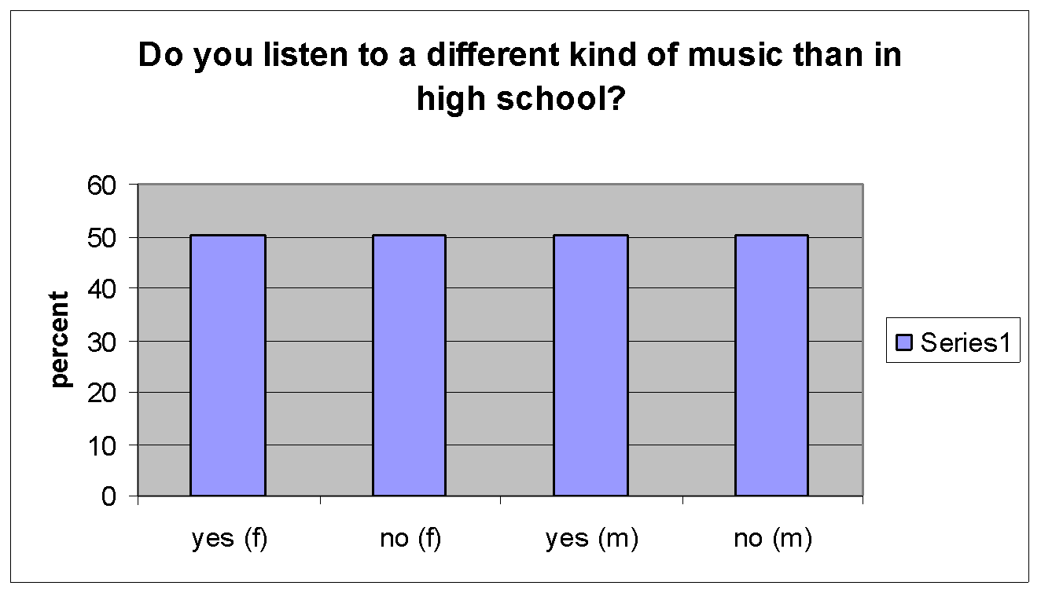

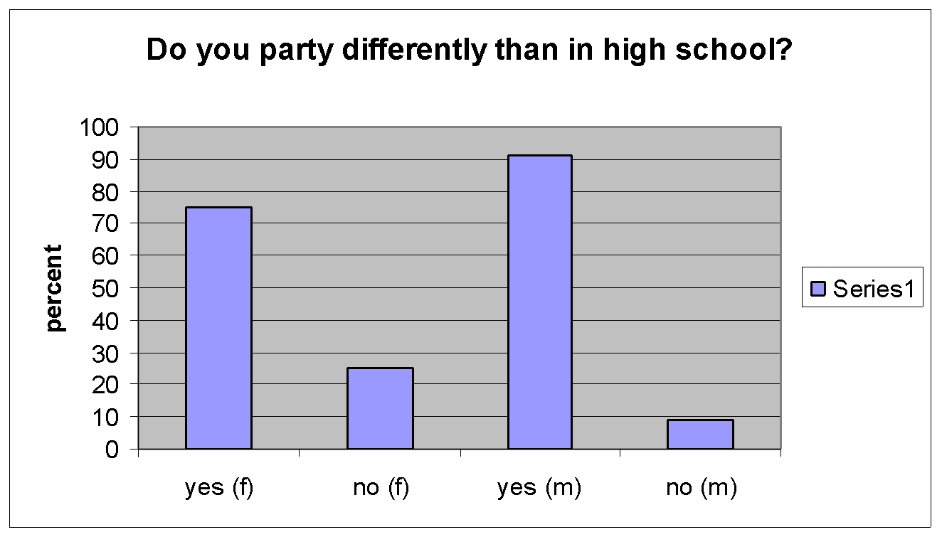

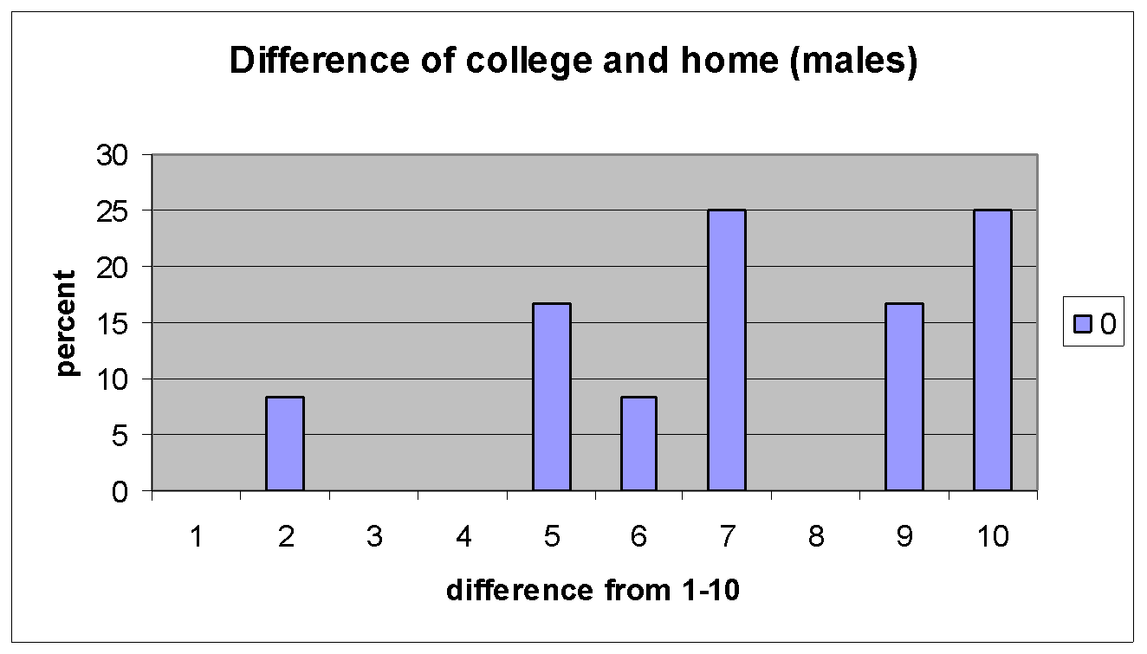

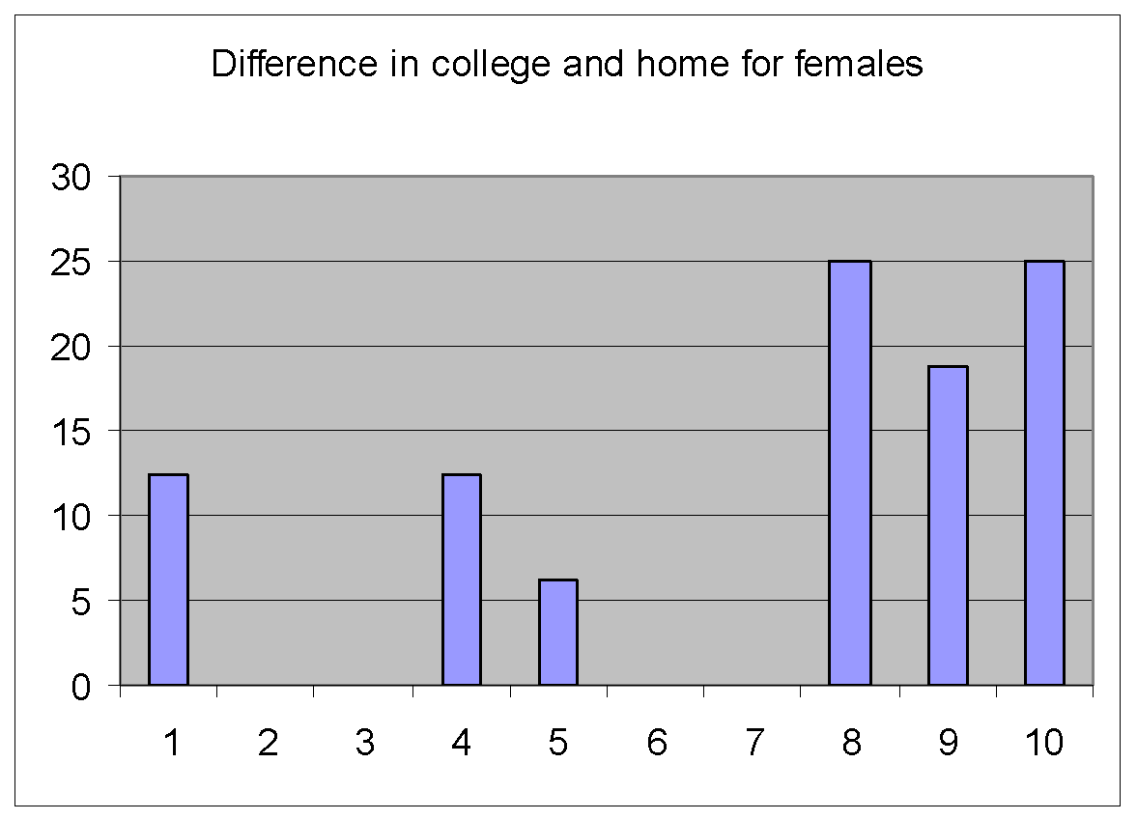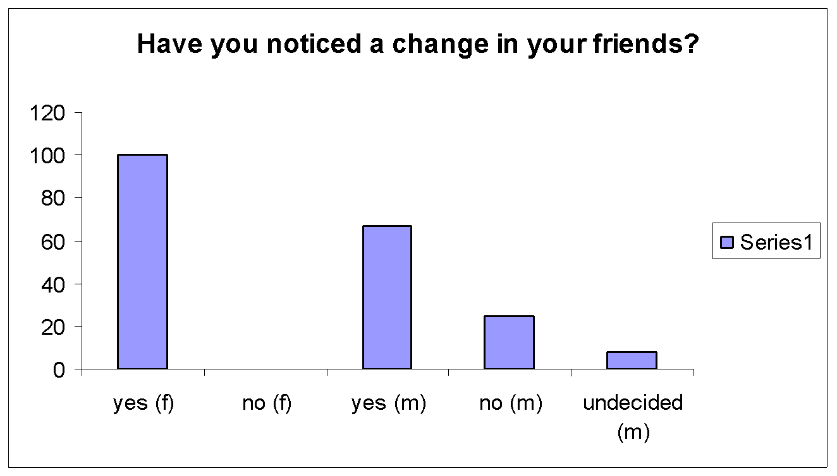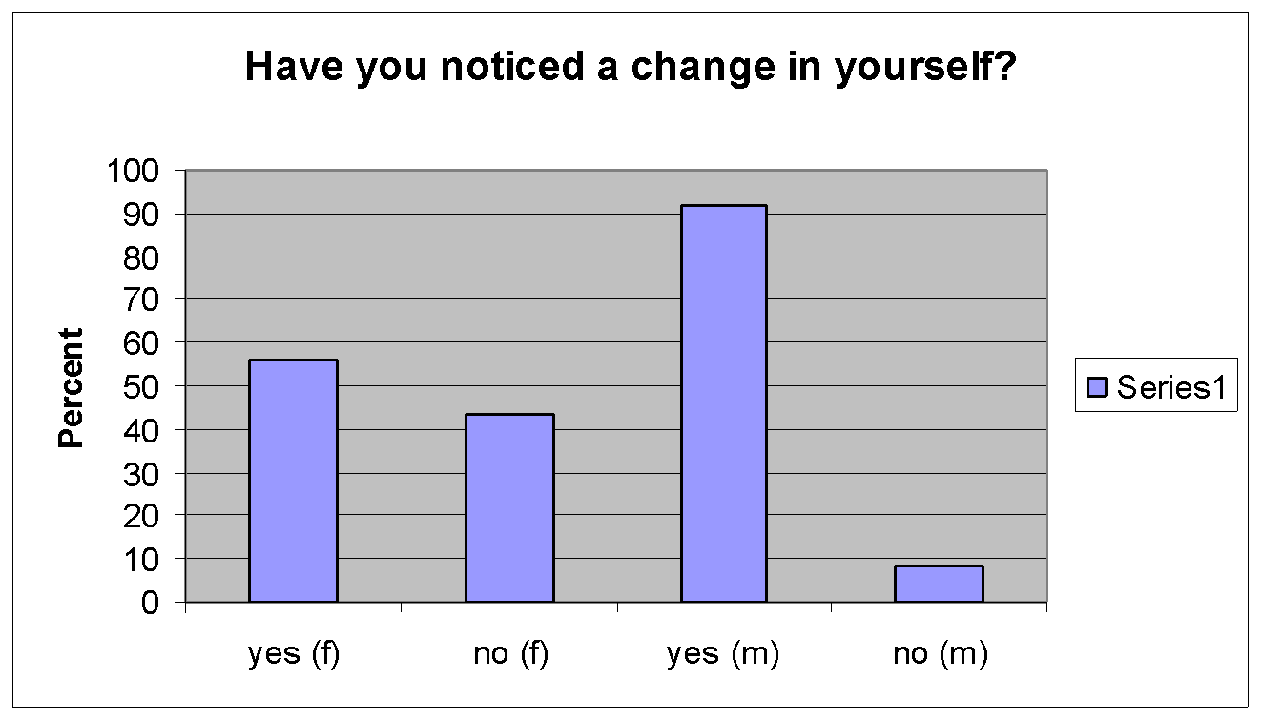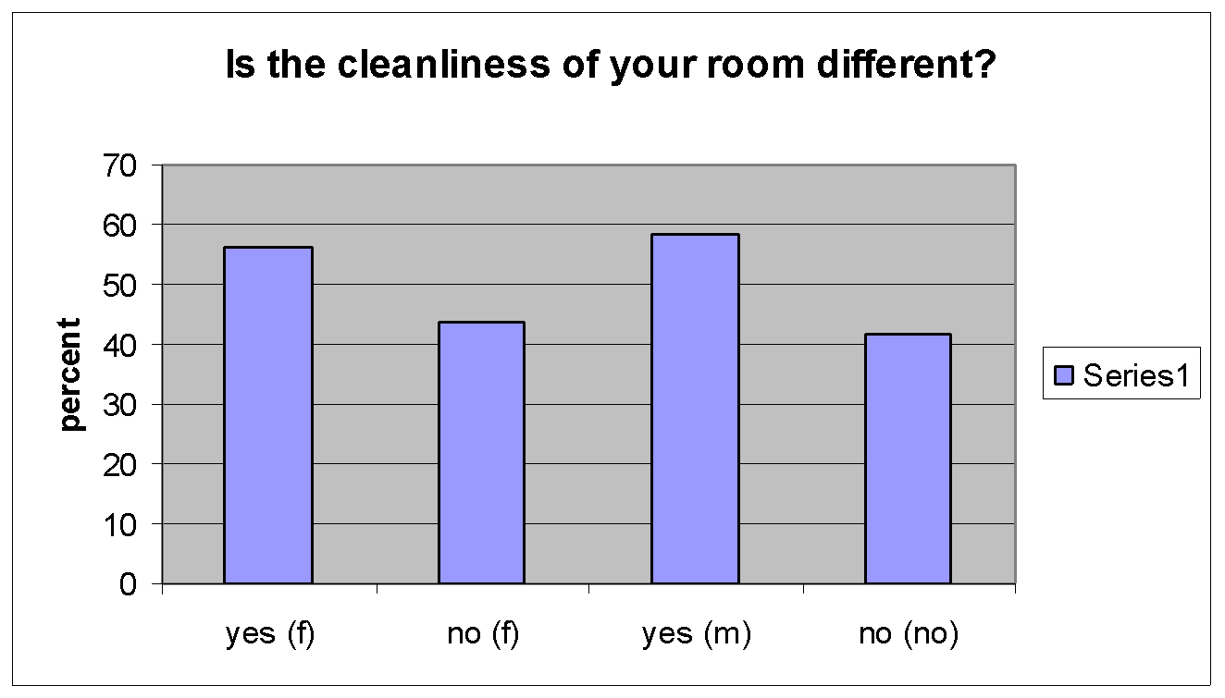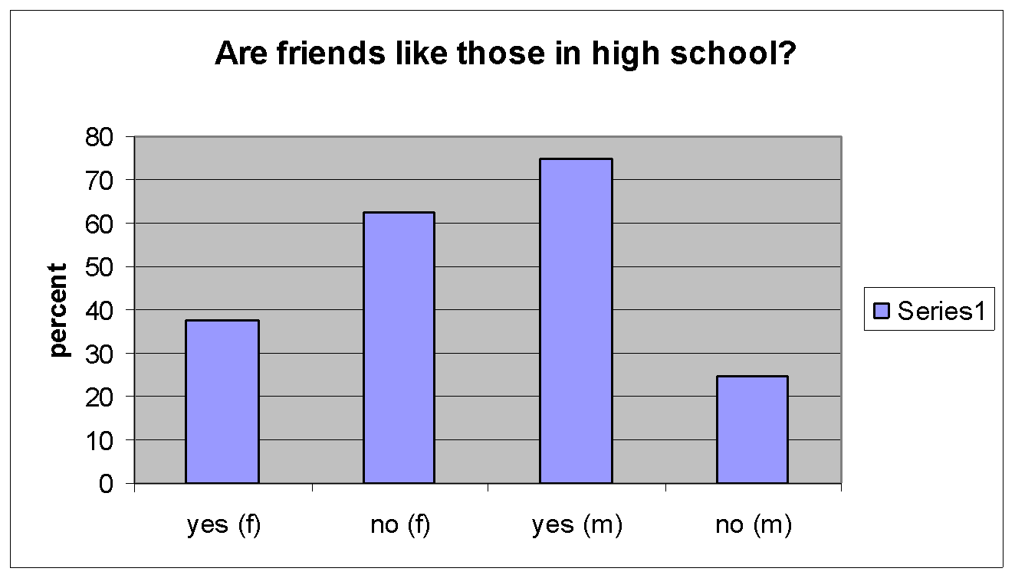

Conclusion

We found that for the most part, the environment of a college student differs immensely with that of their home in high school. With this in mind, females tended to not notice changes in themselves, while almost all males had (91.67%). The results were almost the same when asked if people had noticed a change in them. The difference was that there were a few more females who did not think anyone else had noticed a change in them. 100% of the females felt that their high school friends had changed due to college. 66.67% of males felt that their friends from high school had changed. While in this different environment, females were more likely to branch out and have different types of friends (62.5%). Most males had stuck to the same type or the same group of friends as in high school (75%). Since most of the college students share a room, if they did not keep their room clean in high school, while in college they had changed their ways and tried to keep it clean during their first year. It is always believed that once one begins college, they tend to party more with alcohol and sometimes drugs. With both males and females it was apparent that while in college they tended to party more than they did in high school (75 % of females and 91%of males). Some of these changes were drastic, while others there was only a slight difference in alcohol intake than in high school. In both males and females, only 50 % of those surveyed have changed the music they listen to while in college. When they did this, they said their college friends listened to that music also. The changes in this category were interesting; people became more accepting of all types of music if they changed the music. All those surveyed, whether male or female have changed their study habits for the better (87.5% of females and 83.3% of males). Only four admitted to their habits not changing, and the reason was before college they studied as much as they do now.

The results are interesting because the students made comments on how their friends had changed, mostly because they partied or hung out with different types of people. However, when viewing themselves they did not see a change. This shows a biased point of view, which we expected. The only way we would have been able to get non-biased results would be to record changes by being there and seeing them occur. Even then we would still have a biased because it is based on opinion.

Some implications of our experiment is that people could talk to others while taking the experiment, the time of day they took it could affect the results , and because we asked their name they could have chosen not to answer honestly due to what they believed we would think of them afterwards. We tried to address these factors by using the same e-mail every time, asking them what time of day they were taking the survey, and by asking them to be as honest as possible. Beyond that those variables were out of our control. Another implication is we thought that people might just shrug it off, so we tried to e-mail it to people who we knew well and believed would take their time and help us out. We selected randomly form those who knew us to make it unbiased. Another factor that was hard to control was the fact that each of the survey had their names on it. We decided it would be practically impossible to keep it anonymous due to the fact that we administered our survey via e-mail. If we did this experiment again, we would have tried to determine a way that we would have been able to give the survey without knowing the names of the people. If we had been more internet literate, one way we could have achieved this is by creating a web page that people could go to and anonymously give answers to our questions. If someone wanted to repeat this experiment, we would highly recommend this.

An experiment that we would have ideally tried was to purchase a community of mice probably around 20 and change their environments to obverse any adaptations that occurred due to the changes. We would have kept them in the same container for a few weeks as a control. Then we would have developed four or five different environments aside from the control and placed the mice in the different containers rotating them every two weeks and recording any observations of change. We would have kept all our methods of changing the mice in between cages the same by doing the same procedure for each mouse. We would have the environments almost identical but with a small change in each one. This would have been our ideal experiment but we did not think it logical or humane because we would have not been able to keep the mice after the experiment. There are also other pets in each of our houses, which could also have a large affect on the way the mice dealt with environmentally changes. We also had a hard time developing the different kind of environments to put the mice in. Something that would have been difficult in trying to do this is determining the differences in the mice in each environment. Problems that people face when observing other organisms is they try to put emotional feelings on them when in reality; we can’t communicate with them in order to understand their “feelings.”

Bibliography

1.”Cognitive Adapations: A tentative compendium” (online) http://cogweb.ucla.edu/EP/Adapations.html

2.”Leadership Letters” (online) <http://www.leadershipletters.com/letters/letter17.htm>

3.